Week 7 -React Handson

Hands-on 1: Creating a react app ‘cricketapp’

1. Creating new React app named ‘cricketapp’ using create-react-app

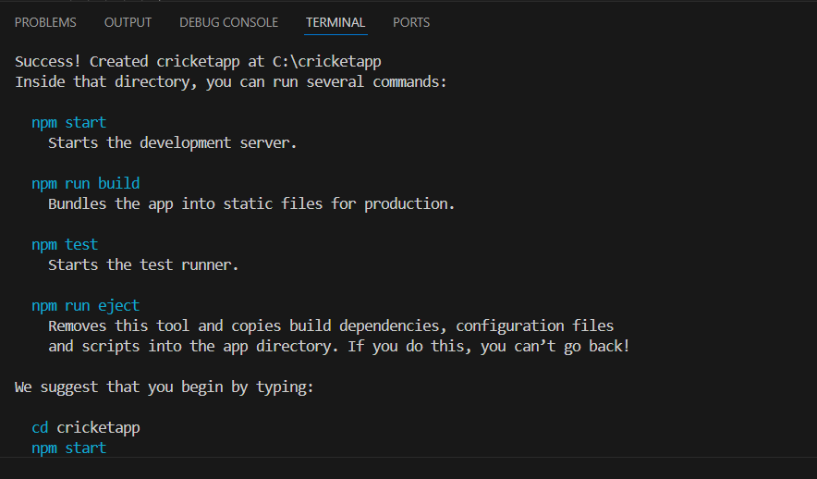

1. Creating a component named ’ListOfPlayers’ inside the component folder
2. Inside the ListOfPlayers component creating an array of 11 players with their details such as name and score

File name: ListOfPlayer.js

import React from "react";

const ListOfPlayers=()=>{

const players=[

{name:"Virat Kohli" , score:"80"},

{name:"Dhoni" , score:"90"},

{name:"Jadeja" , score:"70"},

{name:"Raahul" , score:"75"},

{name:"Rohit sharma" , score:"80"},

{name:"Hardik Pandya" , score:"65"},

{name:"Bumrah" , score:"70"},

{name:"Shami" , score:"60"},

{name:"Washington Sundar" , score:"55"},

{name:"Sai Sudharshan" , score:"55"},

{name:"Surya", score:"75"}

]

const filterePlayers=players.filter(player => player.score<=70);

return(

<div>

<h2>List of Players</h2>

<ul>

{players.map((player , index)=>(

<li key={index}>{player.name}-{player.score}</li>

))}

</ul>

<h2>Players with score less than 70</h2>

<ul>

{filterePlayers.map((player , index)=>(

<li key={index}>{player.name}-{player.score}</li>

))}

</ul>

</div>

)

}

export default ListOfPlayers;

1. Creating a component named ’IndianPlayers’ inside the component folder
2. Declaring two arrays T20players and RanjiTrophy players and merging the two arrays and displaying them using the Merge feature of ES6

File name: IndianPlayers.js

import React from "react";

const IndianPlayers = () => {

const T20Players = ["Virat", "Rohit", "Pant", "Bumrah"];

const RanitTrophy = ["Gambir", "Pujara", "Rahane", "Ashwin"];

const allPlayers = [...T20Players, ...RanitTrophy];

const oddPlayers = allPlayers.filter((_, index) => index % 2 !== 0);

const evenPlayers = allPlayers.filter((_, index) => index % 2 === 0);

return (

<div>

<h2>All Indian Players</h2>

<ul>

{allPlayers.map((player, index) => (

<li key={index}>{player}</li>

))}

</ul>

<h2>Odd Players</h2>

<ul>

{oddPlayers.map((player, index) => (

<li key={index}>{player}</li>

))}

</ul>

<h2>Even Players</h2>

<ul>

{evenPlayers.map((player, index) => (

<li key={index}>{player}</li>

))}

</ul>

</div>

);

};

export default IndianPlayers;

1. Modifying the App.js to render these components

File name: App.js

import './App.css';

import ListOfPlayers from './components/ListOfPlayers';

import IndianPlayers from './components/IndianPlayers'

function App() {

const flag=false;

return (

<div>

<h1>Cricket App</h1>

{flag?<ListOfPlayers/>:<IndianPlayers/>}

</div>

);

}

export default App;

OUTPUT:

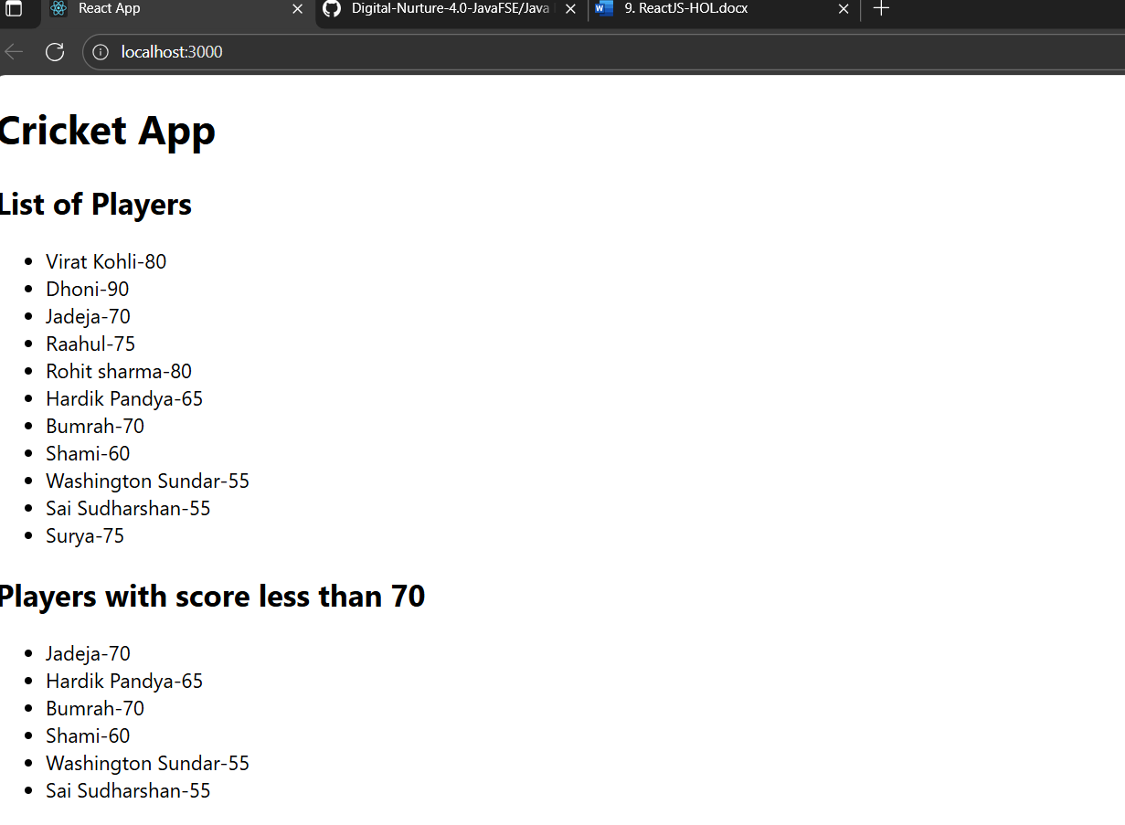

1. Changing the flag to false

OUTPUT:

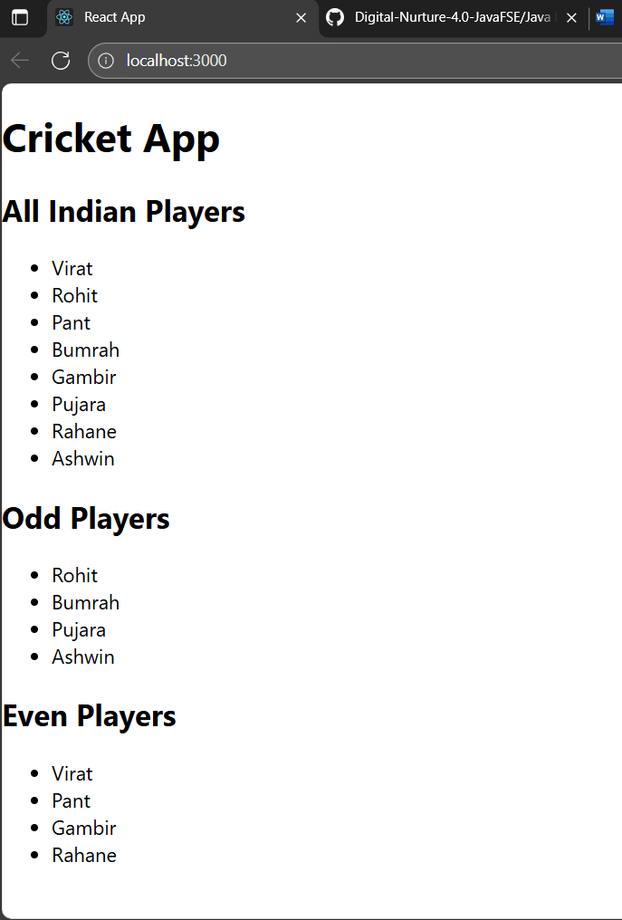

Handson-2: Creating a react app ‘officespacerentalapp’

1. Creating a app named ‘officespacerentalapp’ using create-react-app

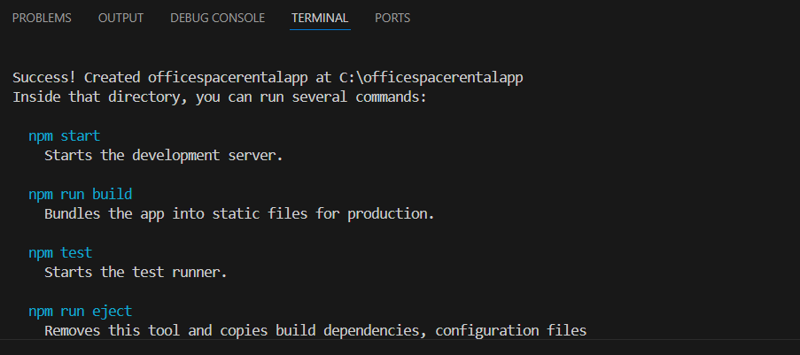

1. We modify the “App.js” to use inline CSS and JSX to render the Office Image, Name, Address and Rental cost

File name: App.js

import React from 'react';

function App() {

const offices = [

{

id: 1,

name: 'Nexa work space',

rent: 55000,

address: '15th Street, Gandhi Nagar, Chennai',

image: './off1.png'

},

{

id: 2,

name: 'Green Park',

rent: 70000,

address: '5th Avenue, Anna Nagar, Chennai',

image: './off2.png'

},

];

const headingStyle = {

textAlign: 'center',

color: '#333'

};

return (

<div>

<h1 style={headingStyle}>Office Space Rental App</h1>

{offices.map((office) => (

<div key={office.id} style={{ border: '1px solid #ccc', margin: '10px', padding: '10px' }}>

<img src={office.image} alt={office.name} width="300" height="200" />

<h2>{office.name}</h2>

<p><strong>Address:</strong> {office.address}</p>

<p>

<strong>Rent:</strong>{' '}

<span style={{ color: office.rent < 60000 ? 'red' : 'green' }}>

₹{office.rent}

</span>

</p>

</div>

))}

</div>

);

}

export default App;

OUTPUT:

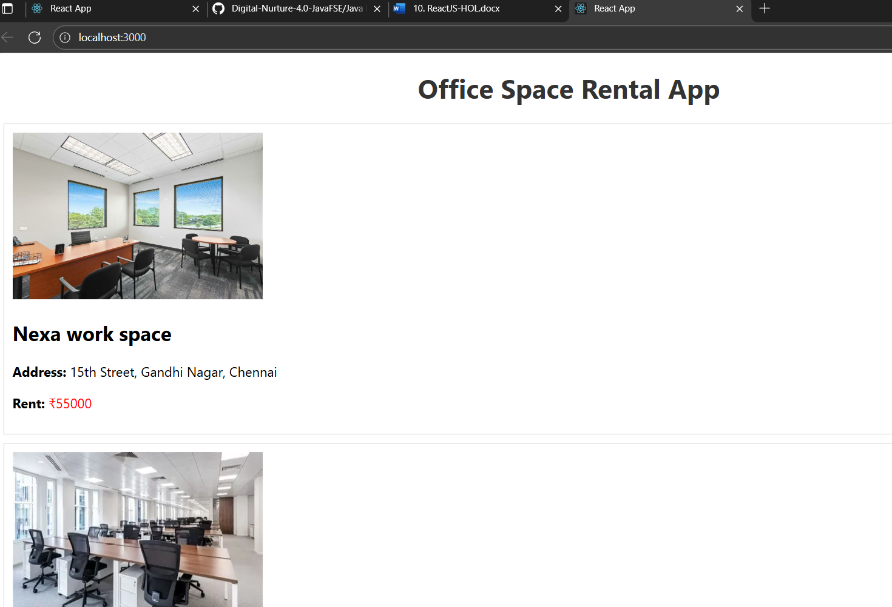

Handson-3: Creating a react app ‘eventexamplesapp’

1. Creating a react app named ‘eventexamplesapp’ using create react application

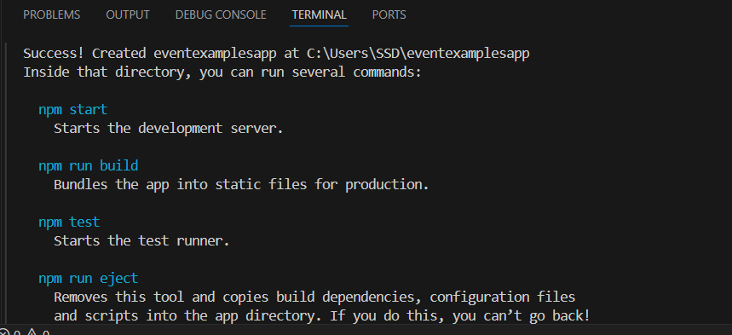

1. Creating the components folder inside the src folder. Inside the components folder creating the CounterAndConvertor component

File name: CounterAndConvertor.js

import React, { useState } from "react";

const CounterAndConverter = () => {

const [count, setCount] = useState(0);

const [message, setMessage] = useState("");

const [inr, setInr] = useState("");

const [euro, setEuro] = useState("");

const conversionRate = 0.011;

const handleIncrement = () => {

incrementValue();

sayHello();

};

const incrementValue = () => {

setCount(prev => prev + 1);

};

const decrementValue = () => {

setCount(prev => prev - 1);

};

const sayHello = () => {

setMessage("Hello! This is a static message.");

};

const sayWelcome = (word) => {

alert("Say Welcome button was pressed");

setMessage(Say ${word});

};

const handleClick = () => {

alert("Synthetic OnPress button was pressed");

setMessage("I was clicked");

};

const handleConvert = (e) => {

e.preventDefault();

const inrValue = parseFloat(inr);

if (!isNaN(inrValue)) {

const converted = (inrValue * conversionRate).toFixed(2);

setEuro(converted);

setMessage(${inrValue} INR = ${converted} EUR);

alert(Converted: ₹${inrValue} = €${converted});

} else {

setMessage("Please enter a valid number.");

}

};

return (

<div style={{ padding: 20 }}>

<h2>Counter: {count}</h2>

<button onClick={handleIncrement}>Increment</button>

<button onClick={decrementValue}>Decrement</button>

<br /><br />

<button onClick={() => sayWelcome("Welcome")}>Say Welcome</button>

<br /><br />

<button onClick={handleClick}>Synthetic OnPress</button>

<br /><br />

<h3>Currency Converter (INR ➜ Euro)</h3>

<form onSubmit={handleConvert}>

<input

type="number"

placeholder="Enter INR"

value={inr}

onChange={(e) => setInr(e.target.value)}

/>

<button type="submit">Convert</button>

</form>

{euro && <p>Converted Amount: €{euro}</p>}

<h4>Message: {message}</h4>

</div>

);

};

export default CounterAndConverter;

File name: App.js

import React from "react";

import CounterAndConverter from "./components/CounterAndConvertor";

function App() {

return (

<div>

<CounterAndConverter/>

</div>

);

}

export default App;

OUTPUT:

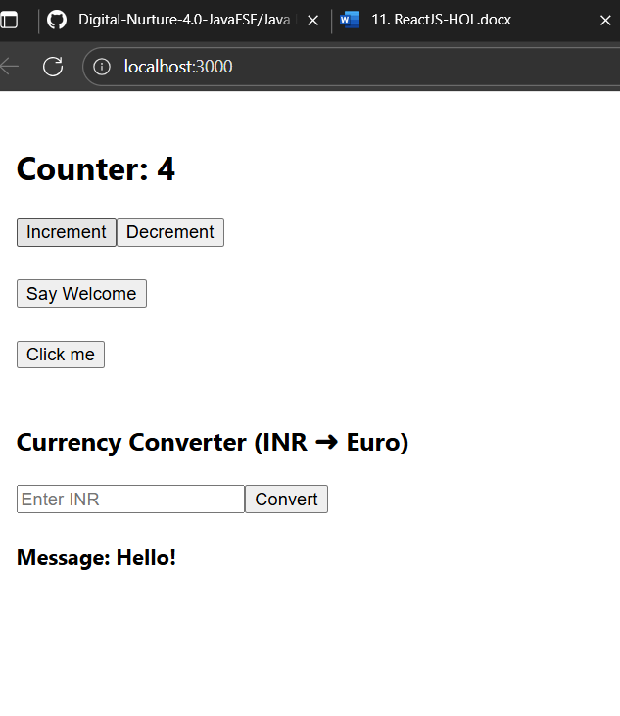

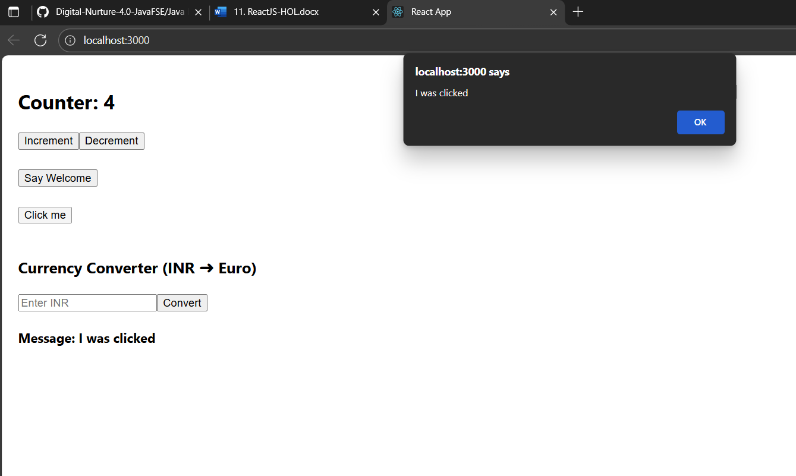

Converting INR to EURO

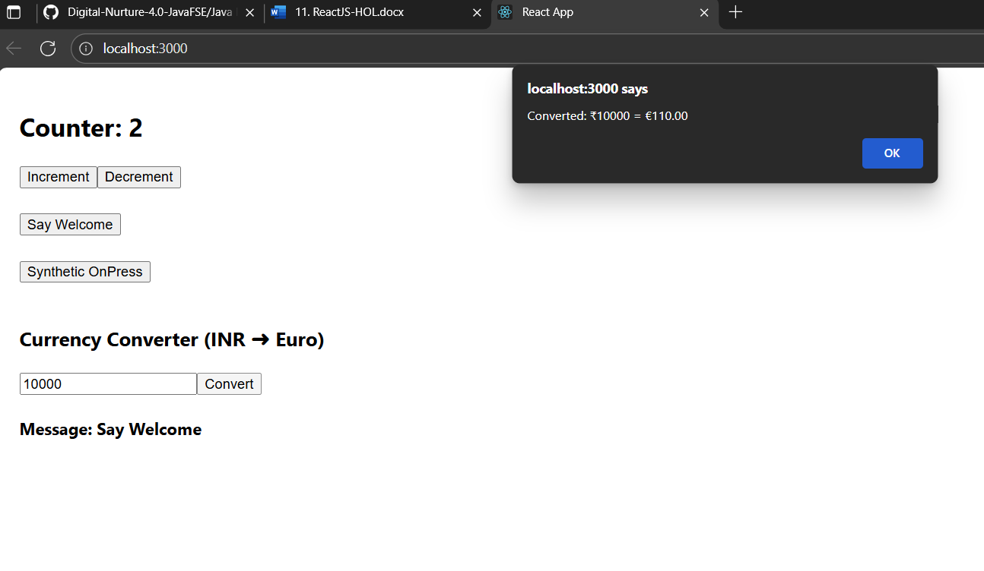

Hands-on 4: Creating a react Ticket booing app

1. Creating a react app named ‘ticketbookingapp’ using create-react-app

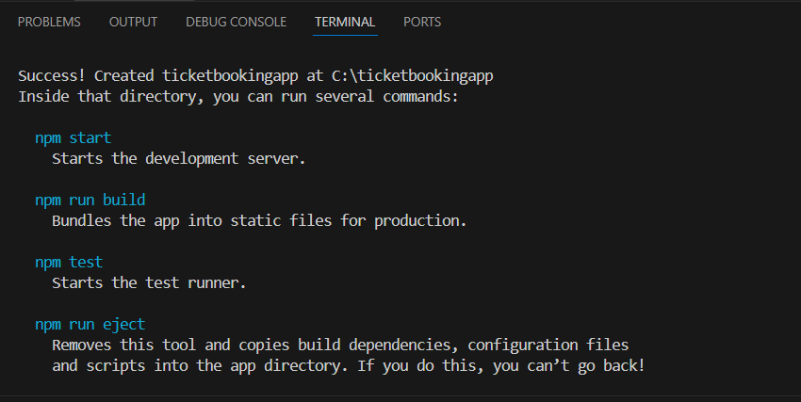

1. Creating a components folder under the src folder
2. Inside the components folder creating the following components Login.js , Logout.js, GuestPage.js, UserPage.js

File name: Login.js

import React from "react";

const Login = ({ onLogin }) => {

  return (

    <button onClick={onLogin} style={{ marginBottom: "10px" }}>

      Login

    </button>

  );

};

export default Login;

File name:Logout.js

import React from "react";

const Logout = ({ onLogout }) => {

  return (

    <button onClick={onLogout} style={{ marginBottom: "10px" }}>

      Logout

    </button>

  );

};

export default Logout;

File name: GuestPage.js

import React from "react";

const GuestPage = () => {

  return (

    <div>

      <h2>Guest View</h2>

      <p>Available Flights:</p>

      <ul>

        <li>Chennai to Bangalore - ₹2500</li>

        <li>Delhi to Mumbai - ₹4500</li>

        <li>Hyderabad to Kolkata - ₹3000</li>

      </ul>

    </div>

  );

};

export default GuestPage;

File name:UserPage.js

import React from "react";

const UserPage = () => {

  return (

    <div>

      <h2>User Dashboard</h2>

      <p>You can now book your flights below:</p>

      <ul>

        <li>Chennai to  Bangalore <button>Book</button></li>

        <li>Delhi to  Mumbai <button>Book</button></li>

        <li>Hyderabad to  Kolkata <button>Book</button></li>

      </ul>

    </div>

  );

};

export default UserPage;

1. Now modifying the App.js to render these components

import React, { useState } from "react";

import Login from "./components/Login";

import Logout from "./components/Logout";

import GuestPage from "./components/GuestPage";

import UserPage from "./components/UserPage";

function App() {

const [isLoggedIn, setIsLoggedIn] = useState(false);

return (

<div style={{ padding: "20px", fontFamily: "Arial" }}>

<h1> Ticket Booking App</h1>

{isLoggedIn ? (

<>

<Logout onLogout={() => setIsLoggedIn(false)} />

<UserPage />

</>

) : (

<>

<Login onLogin={() => setIsLoggedIn(true)} />

<GuestPage />

</>

)}

</div>

);

}

export default App;

OUTPUT:

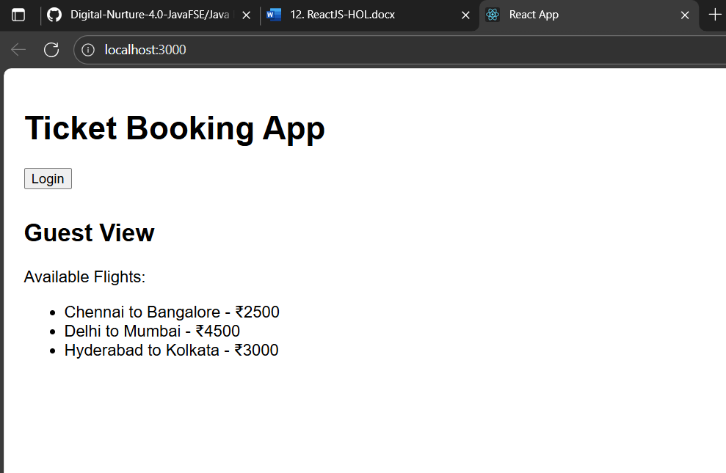

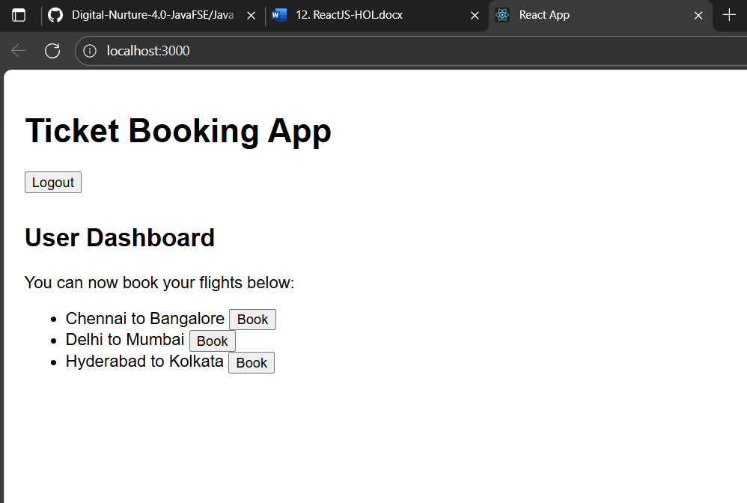

Hands-on 5: Creating a react bloggerapp

1. Creating a react app named ‘bloggerapp’ using create-react-app

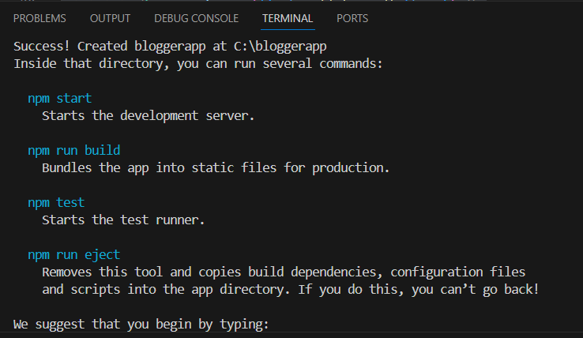

1. Creating a folder components inside the src folder. Inside the components folder creating the following components

File name: BookDetails.js

import React from "react";

const BookDetails = () => {

  return (

    <div>

      <h2>Book Details</h2>

      <p>Title: React Simplified</p>

      <p>Author: John Doe</p>

    </div>

  );

};

export default BookDetails;

File name: BlogDetails.js

import React from "react";

const BlogDetails = () => {

  return (

    <div>

      <h2>Blog Details</h2>

      <p>Title: Learning React in 2025</p>

      <p>Author: Jane Smith</p>

    </div>

  );

};

export default BlogDetails;

File name:CourseDetials.js

import React from "react";

const CourseDetails = () => {

  return (

    <div>

      <h2>Course Details</h2>

      <p>Course: Full Stack Development</p>

      <p>Duration: 3 Months</p>

    </div>

  );

};

export default CourseDetails;

OUTPUT (Book Details):

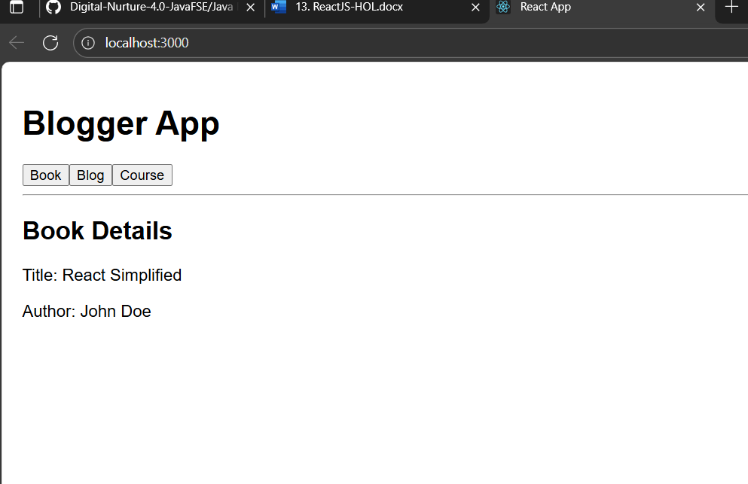

Blog Details

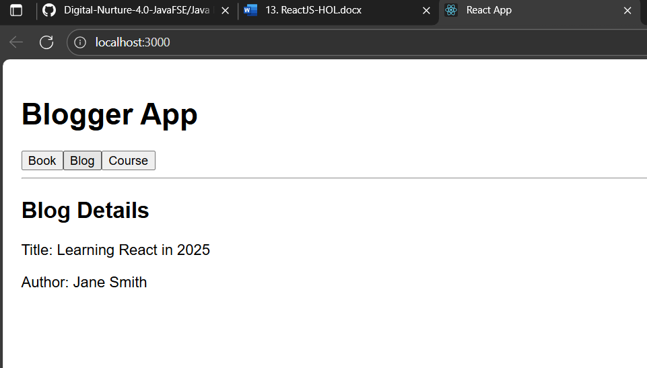

Course Details

